

System design SPECIFICATION
for
system administration

Release No 1.0– Mar,2022

Document History

Document Identification no | Document Title | Status  (draft/ approved/ baselined/ released ) | Date of Release | Pages
eCMS /sds/01/V1.0 | System design specification for system administration | draft

Prepared By
Role | Name | Signature | Date (dd-mm-yyyy)

Reviewed by

Role | Name | Signature | Date (dd-mm-yyyy)

Approved By
Role | Name | Signature | Date (dd-mm-yyyy)
application system Manager

Authorized for Release
 | Name | Designation | Signature | Date (dd-mm-yy)
Authorized by Project Manager

Contents
1. INTRODUCTION 4
1.1 Scope 4
1.2 Definitions and abbreviations 4
1.3 References 5
1.4 Product Perspective 5
2. Design Considerations 6
3. Architectural Strategies 9
4. System Architecture 10
5. Design viewpoints 11
5.1 Audit trail overview 11
5.2 Audit Trail Data Collector 11
5.3 Audit Type 11
5.4 Viewing Audit Trail 11
5.5 interface Viewpoints 12
6 Code Maintenance overview 12
6.1 Code maintenance to create, update, view 12
7 Reset Password overview 13
8 Notice and update overview 14
9 Resource Management System overview 14
10 Calendar configuration 15
11 Work shift Assignment 15
12 setup of vacation period of custom officers 16
13 Task Configuration 17
14 Pending 17
15 Dependency viewpoint 19
16 system database schema 20
17 field details 20

INTRODUCTION

The eCMS, as its name implies, will be a system for the DRC’s Customs & Excise Division, hereafter referred to as “Customs”, that will provide best-in-class services to the Bhutan‘s business community, in support of the Bhutan‘s aspirations to modernize core customs administration functions as part of customs modernization requirements and in line with the international conventions and national regulations such as The Customs Act of Bhutan 2017 and Customs Rules and Regulations of Bhutan 2017.

Implementation of the electronic customs management system will further help to propel Bhutan’s rankings by making it easier and clearer for traders and businesses to have access to information and enable them to submit regulatory compliance forms/documents digitally.

This document is intended to act as the SDD (Software Design Document) for the System Administration. This document defines & illustrates the business requirements, how system can work as well as the detailed functional requirements of eCMS System Administration module to be implemented for Department of Revenue and Customs Bhutan

Scope
Registration of a party and user is one of the core functions of eCMS. This module takes care of the following activities:
• Registration of a Party
• Registration of a User

Definitions and abbreviations

Definitions & Abbreviations | Description
eCMS | Electronic Customs Management System
DRC | Department of Revenue & Custom
DITT | Department of Information Technology & Telecom
YK | Yang Khor
CL | Crimsonlogic
VSTS | Visual Studio and Team Services
SIT | System Integration Test
UAT | User Acceptance Test
CBP | Configuration Blueprint
SRS | Software Requirements Specification
EIS | External Interface Specification
PD | Project Director
PM | Project Manager
QA | Quality Assurance
SI | System Integration
SME | Subject Matter Expert
QMS | Quality Management System
CR | Change Request
SCCB | Software Change Control Board
SQAR | Software Quality Assurance Representative
V&V AND VnV | Verification and Validation
RAMIS | Revenue Accounting Management Information System
BITS | Bhutan Integrated Tax System

References
Signed off SRS_eCMS_Registration_V1.0

Product Perspective

Design Considerations

Below is the summary of the aspects which were considered during design.

- Compatibility - The system can operate with other products that are designed for interoperability. Standard WCO data model and recommended WCO Customs processes are followed for the System to integrate and communicate with other similar Customs system.
- Extensibility - New capabilities can be added to the software without major changes to the underlying architecture and this is achieved by identifying and making components highly configurable wherever possible and, also, the framework supports some degree of on-the-fly Customization to extend functionality with minimum effort.
- Modularity - The resulting software comprises well defined, independent components which leads to better maintainability. The components could be then implemented and tested in isolation before being integrated to form a desired software system. This allows division of work in a software development project.
- Fault-tolerance - The software is resistant to and able to recover from component failure. Well defined error messages for various anticipated behavior are catered and provided for.
- Maintainability – This is a measure of how easily bug fixes or functional modifications can be accomplished. High maintainability can be the product of modularity and extensibility.
- Reliability (Software durability) - The software can perform a required function under stated conditions for a specified period.
- Reusability - The ability to use some or all the aspects of the preexisting software with little to no modification.
- Robustness - The software can operate under stress or tolerate unpredictable or invalid input.
- Security - The software can withstand and resist hostile acts and influences.
- Usability - The software user interface must be usable for its target user/audience. Default values for the parameters must be chosen so that they are a good choice for most of the users.
- Performance - The software performs its tasks within a timeframe that is acceptable for the user.
- Portability - The software should be usable across several different conditions and environments.
- Scalability - The software adapts well to increasing data or added features or number of users.

- Resource Managements
The setup for customs Admin and supervisor includes the following:
- Calendar year configuration
- Work shift assignment
- Setup vacation period of custom officers
- Task Configuration
- Pending tasks

- Calendar year Configuration
In the calendar year configuration, there are 4 tabs which requires setup:
- Calendar
  - Setup for calendar year.

- Work week
  - Setup of office hours for each day of the week.

- Work Shifts
  - Working shifts
  - Each custom officer is assigned a work shift when on duty.

- Holidays
  - Setup for eCMS to recognize public holidays

- Work Shift Assignment
This setup the custom officer’s “work shift” and the start and end date of the work shift assignment.

Here are the field needs to be setup:
- User ID – custom office user id. This is the ID which has been setup in the Registration-CMS User.
- From Date and To Date – the start and end of the configured work shift.
- Shift Name – This is the shift defined during the setup of the calendar.
- Active – it is valid.

- Task Configuration
This is the setup of the task and the roles of the assigned modules.

Here are the field needs to be setup:
- Task code – task code, unique.
- Task Name – Description of the task
- Module – Module for this task.
- Role – eCMS will only display the roles which is tied to the module. The role of the custom officers assigned to this task. This is tied to the CMS user’s role.
- Party – once set, it is only for the defined organization i.e. Customs.
- Customs office – once set, it is valid for the defined custom office.
- Algorithm
  - Round Robin – each office is assigned a task assigned fairly.
- Due dates (from creation date)
  - Days – number of days for the task to be completed once assigned.
  - Type of Days – Working days/Calendar days. Calendar days mean weekend included while working days is tied to the work week as setup.

- Pending Tasks
This is used for reassignment of task to another officer. Supervising officer will use the function to assign task to another officer.

- Resource Assignment
There are 2 ways for resources to be assigned to a task manual and automatically

Architectural Strategies

Microservices architecture pattern is seen as a viable alternative to monolithic applications and service-oriented architectures. The components are deployed as separate units through an effective, streamlined delivery pipeline. The pattern’s benefits are enhanced scalability and a high degree of decoupling within the application.

Owing to its decoupled and independent characteristics, the same components can be separately developed, deployed, and tested without interdependency on any other service component.

The benefit of decomposing an application into different smaller services are numerous:

Modularity: This makes the application easier to understand, develop, test, and become more resilient to architecture erosion.

Scalability: Since microservices are implemented and deployed independently of each other, i.e., they run within independent processes, they can be monitored and scaled independently.

Distributed development: it parallelizes development by enabling small autonomous teams to develop, deploy and scale their respective services independently. It also allows the architecture of an individual service to emerge through continuous refactoring. Microservice-based architectures facilitate continuous integration, continuous delivery and deployment

System Architecture

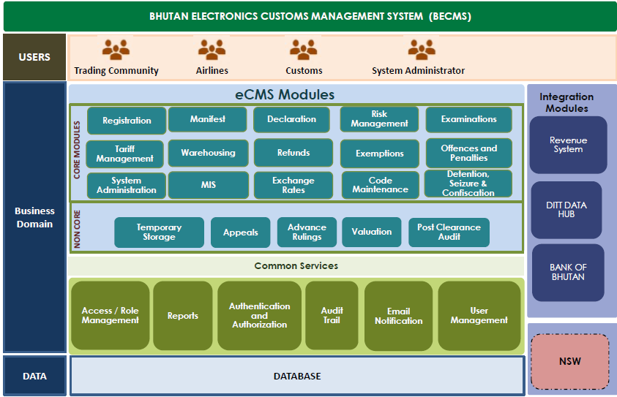

Microservices Architecture

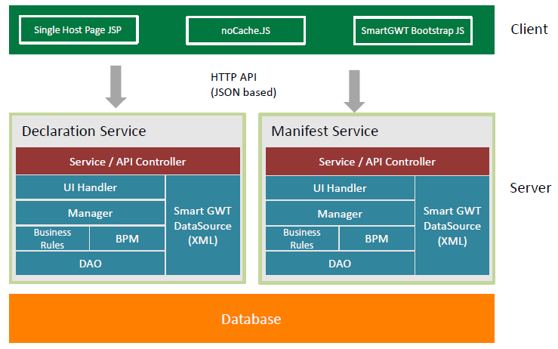

Design viewpoints

Audit trail overview
The Audit Trail module is used to audit various functionalities in eCMS modules by storing the details in audit tables. The Audit Trail module contains mainly two functions. The first one is called Data Collector and the other one is called Data Viewer. All modules in eCMS will have audit logging.

The Audit Trail module is used by the system administrator (Customs) for system auditing and transaction auditing. Detailed audit tracking of each transaction can be done using the Audit Trail module. The Audit Trail module is a centralized module, and it tracks CMS audit. It is comprised of a front end for administrators to query and view a transaction audit log. At the backend all submitted transactions are audit trailed. System events like login/log out etc. will also be audited. The IP of the logged in user will also be tracked in the audit logs.

Audit Trail Data Collector
The Audit Trail Data Collector collects audit data from individual modules. Its function is to receive audit trail data from applications and then store the data in the database.

Audit Type
Audit type defined for the data collector determines if the audit is a transaction audit or a system error or system event. The following audit types are defined:
- Error – Errors & exceptions generated in the system.
- Log – This is general audit information.
- System – System events like system/instance restarts, instance shut down etc.

Viewing Audit Trail

A UI shall be provided for the system admin to view the audit logs. The UI will include filter options & search options to look for audit trail based on:

- Time period of audit
- Module
- User Id
- Audit type

The search page will have a view option to view the audit record. The user will be able to see the data as a name value pair. For e.g. Declaration data will be shown as below:

Declaration Number: DECL1000101
Declaration Type: Import
CPC Group: Import from Home
Destination Country: SG

interface Viewpoints

The Interface design focuses on the screen designs for various services provided by the system administration module.

The screen to apply for system administration for Department of Revenue and Customs Bhutan is provided below.

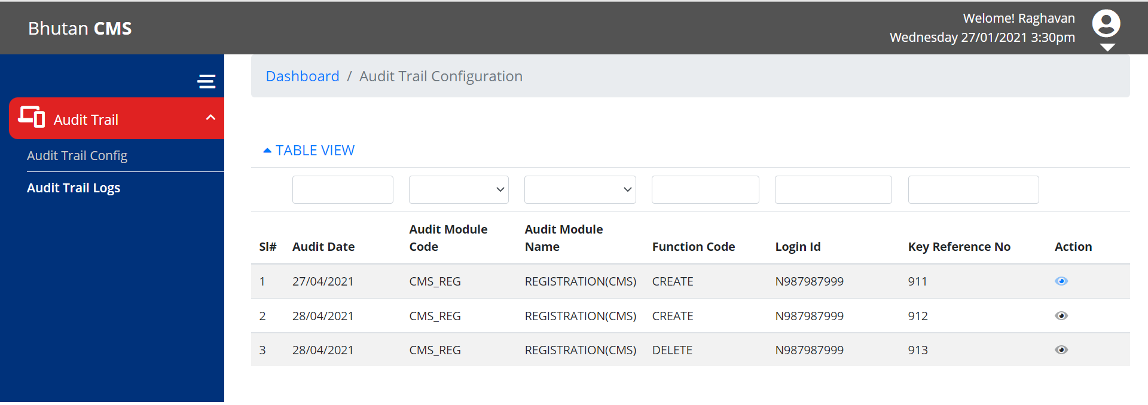

Figure 1.0
Screenshot for system Admin Audit Trail

Code Maintenance overview
Code Maintenance is used to maintain the codes used in eCMS for a set of predefined code type.
Code Maintenance allows for customs officer to create/update, view the code. The code type will be preloaded from the code master. After which, the customs officers can make the necessary updates. The code entered must be unique for that code type.

Code maintenance to create, update, view
Code Maintenance allow for the users to view, add, update.
To add a new code, select the green, ‘+’ from the top right and user will be presented with a page (below). All the user requires to enter the code and description. The code entered must be unique for that code type.

Example, Incoterm code type cannot have duplicate ‘EXW’ code. Validation is done during save process.

The Interface design focuses on the screen designs for various services provided by the system administration module.

The screen to apply for code maintenance for system administration for Department of Revenue and Customs Bhutan is provided below.

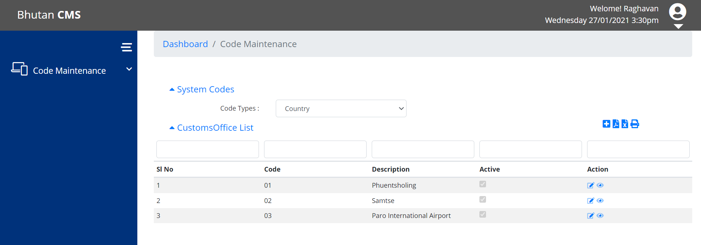

Figure 2.0
Screenshot for system Admin for Code maintenance

Reset Password overview

User can reset password in Registration module. Password automatically generated by system and notification will send to registered user email.
The screen to apply for Reset password for system administration for Department of Revenue and Customs Bhutan is provided below.

Figure 3.0
Screenshot for system Admin for Reset password

Notice and update overview
Admin will create or Update Notice/News under System Admin Module, Once Created/Updated Notice/News will publish on eCMS portal, Users can view the published notice details.
The screen to apply for code maintenance for system administration for Department of Revenue and Customs Bhutan is provided below.

Figure 4.0
Screenshot for system Admin for Notice and update

Resource Management System overview
CMS use the resource management to assign officers to perform certain business functions like document verification, inspection on a specific declaration etc. The assignment is linked to a specific business transaction. The manager/supervisor of the customs office will configure resource management and can manually assign officers to task.
The setup for customs Admin and supervisor includes the following:
- Calendar year configuration
- Work shift assignment
- Setup vacation period of custom officers
- Task Configuration
- Pending tasks
The screen to apply for code maintenance for system administration for Department of Revenue and Customs Bhutan is provided below.
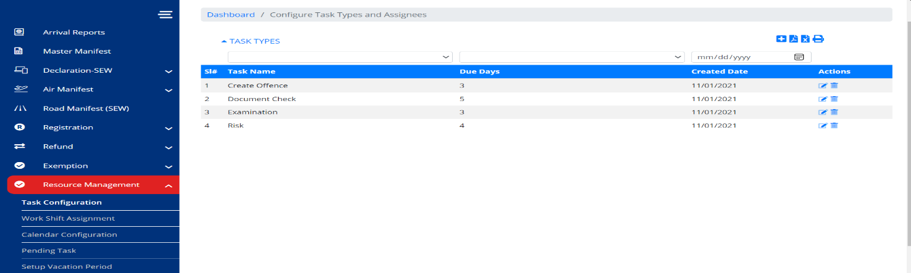

Figure 5.0
Screenshot for system Admin for resource management

Calendar configuration
In the calendar year configuration, there are 4 tabs which requires setup:
- Calendar
  - Setup for calendar year.
- Work week
  - Setup of office hours for each day of the week.
- Work Shifts
  - Working shifts
  - Each custom officer is assigned a work shift when on duty.
- Holidays
  - Setup for eCMS to recognize public holidays

The screen to apply for code maintenance for system administration for Department of Revenue and Customs Bhutan is provided below.

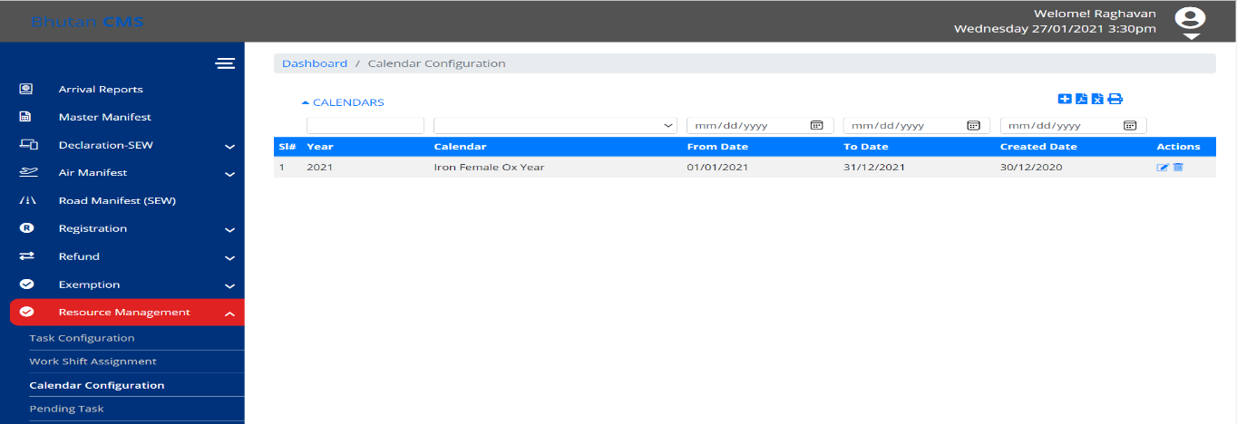

Figure 6.0
Screenshot for system Admin for calendar configuration

Work shift Assignment

This setup the custom officer’s “work shift” and the start and end date of the work shift assignment.
Here are the field needs to be setup:
- User ID – custom office user id. This is the ID which has been setup in the Registration-CMS User.
- From Date and To Date – the start and end of the configured work shift.
- Shift Name – This is the shift defined during the setup of the calendar.
- Active – it is valid.

The screen to apply for work shift Assignment for the System Administration is provided below.

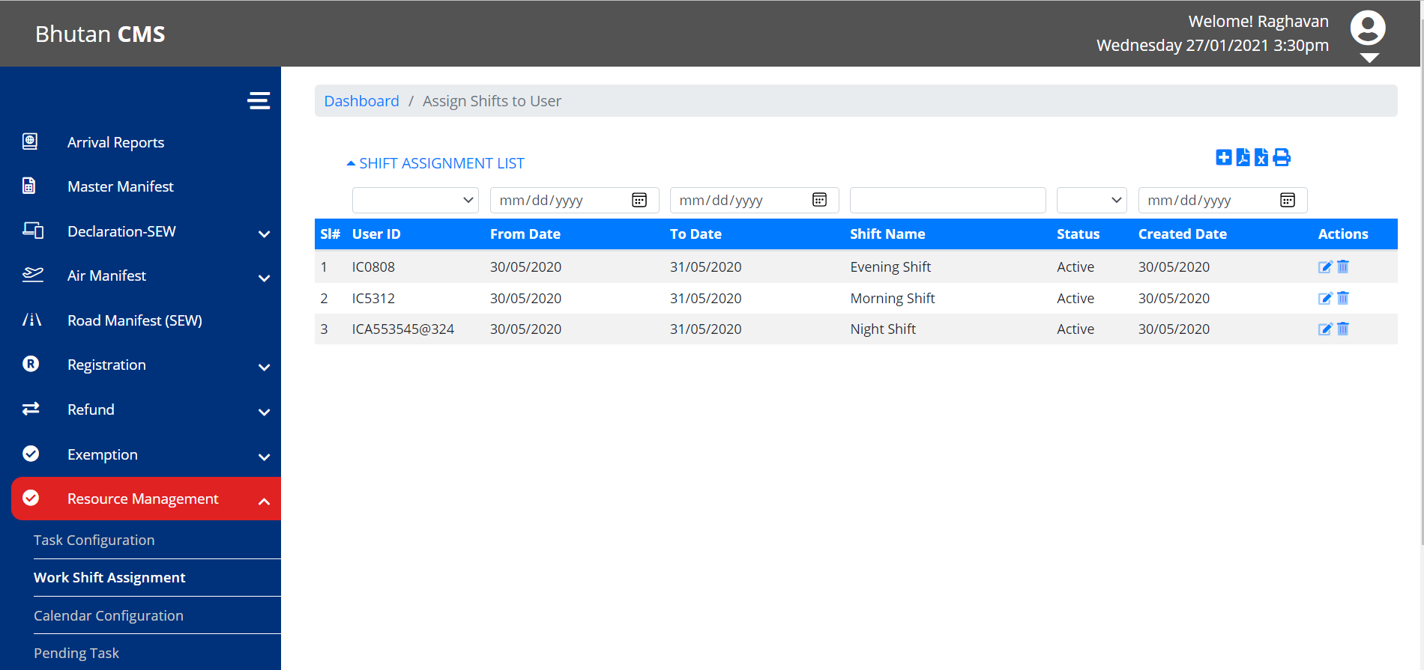

Figure 7.0
Screenshot for system Admin for work shift Assignment

setup of vacation period of custom officers
All custom office needs to setup the vacation period so eCMS assignment engine will know whether an officer is present and can be assignment with new tasks.
Here are the field needs to be setup:
- User ID – custom office user id.
- From Date and to date - Start and end date of vacation.
- Remark - description.
- Active – value for eCMS assignment engine to know whether custom office is on vacation.
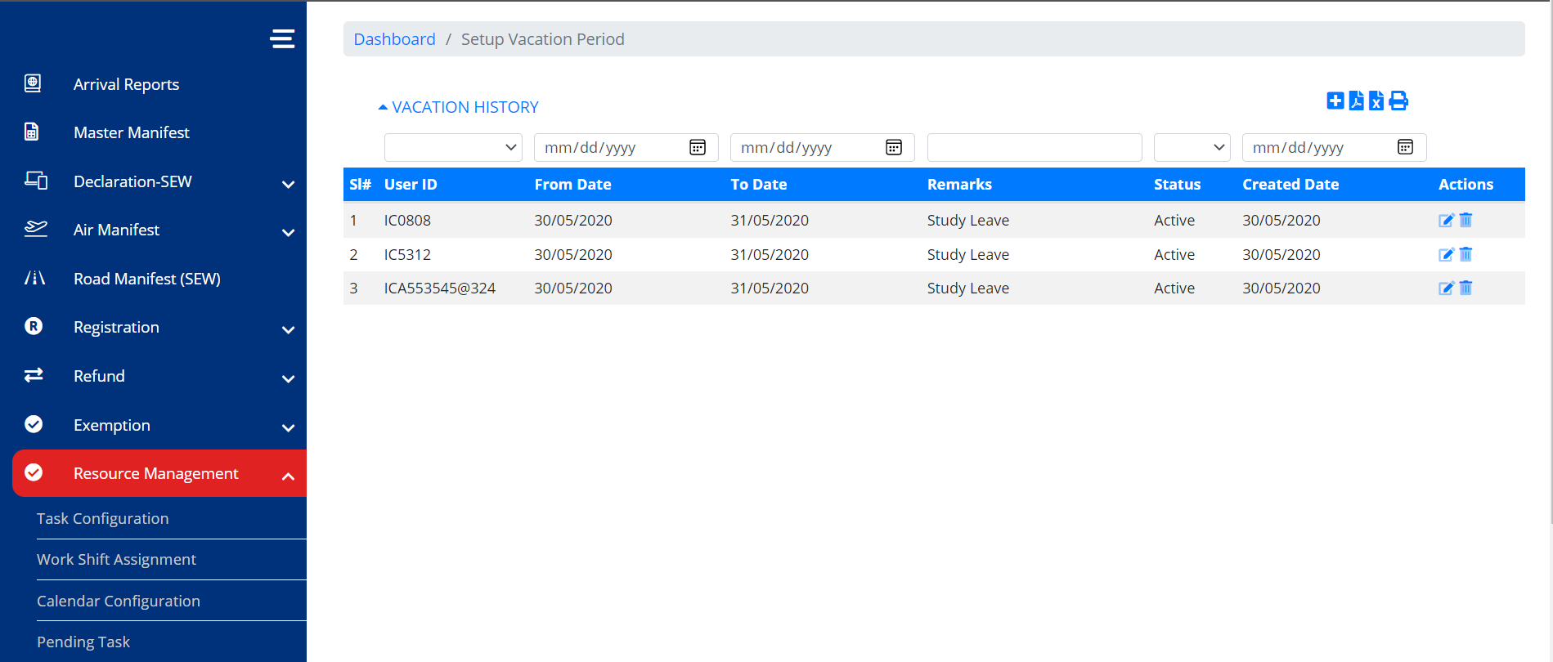
Figure 8.0
Screenshot for system Admin for setup of vacation period customs

Task Configuration

This is the setup of the task and the roles of the assigned modules.
Here are the field needs to be setup:
- Task code – task code, unique.
- Task Name – Description of the task
- Module – Module for this task.
- Role – eCMS will only display the roles which is tied to the module. The role of the custom officers assigned to this task. This is tied to the CMS user’s role.
- Party – once set, it is only for the defined organization i.e. Customs.
- Customs office – once set, it is valid for the defined custom office.
- Algorithm
  - Round Robin – each office is assigned a task assigned fairly.
- Due dates (from creation date)
  - Days – number of days for the task to be completed once assigned.
  - Type of Days – Working days/Calendar days. Calendar days mean weekend included while working days is tied to the work week as setup.

The screen to apply for Task Configuration for the System Administration is provided below.

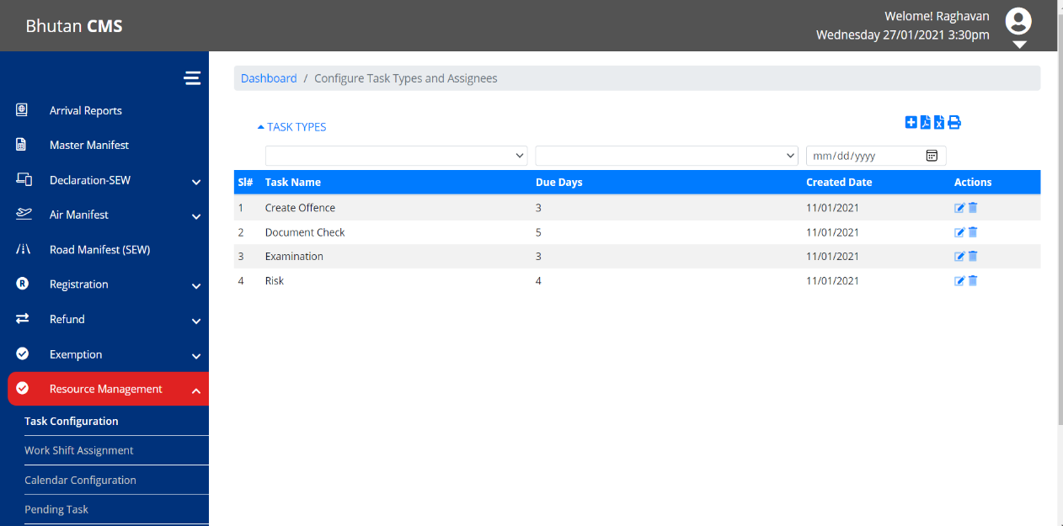
Figure 9.0
Screenshot for system Admin for setup of Task configuration for customs

Pending

This is used for reassignment of task to another officer. Supervising officer will use the function to assign task to another officer.
The screen to apply for Task Configuration for the System Administration is provided below.

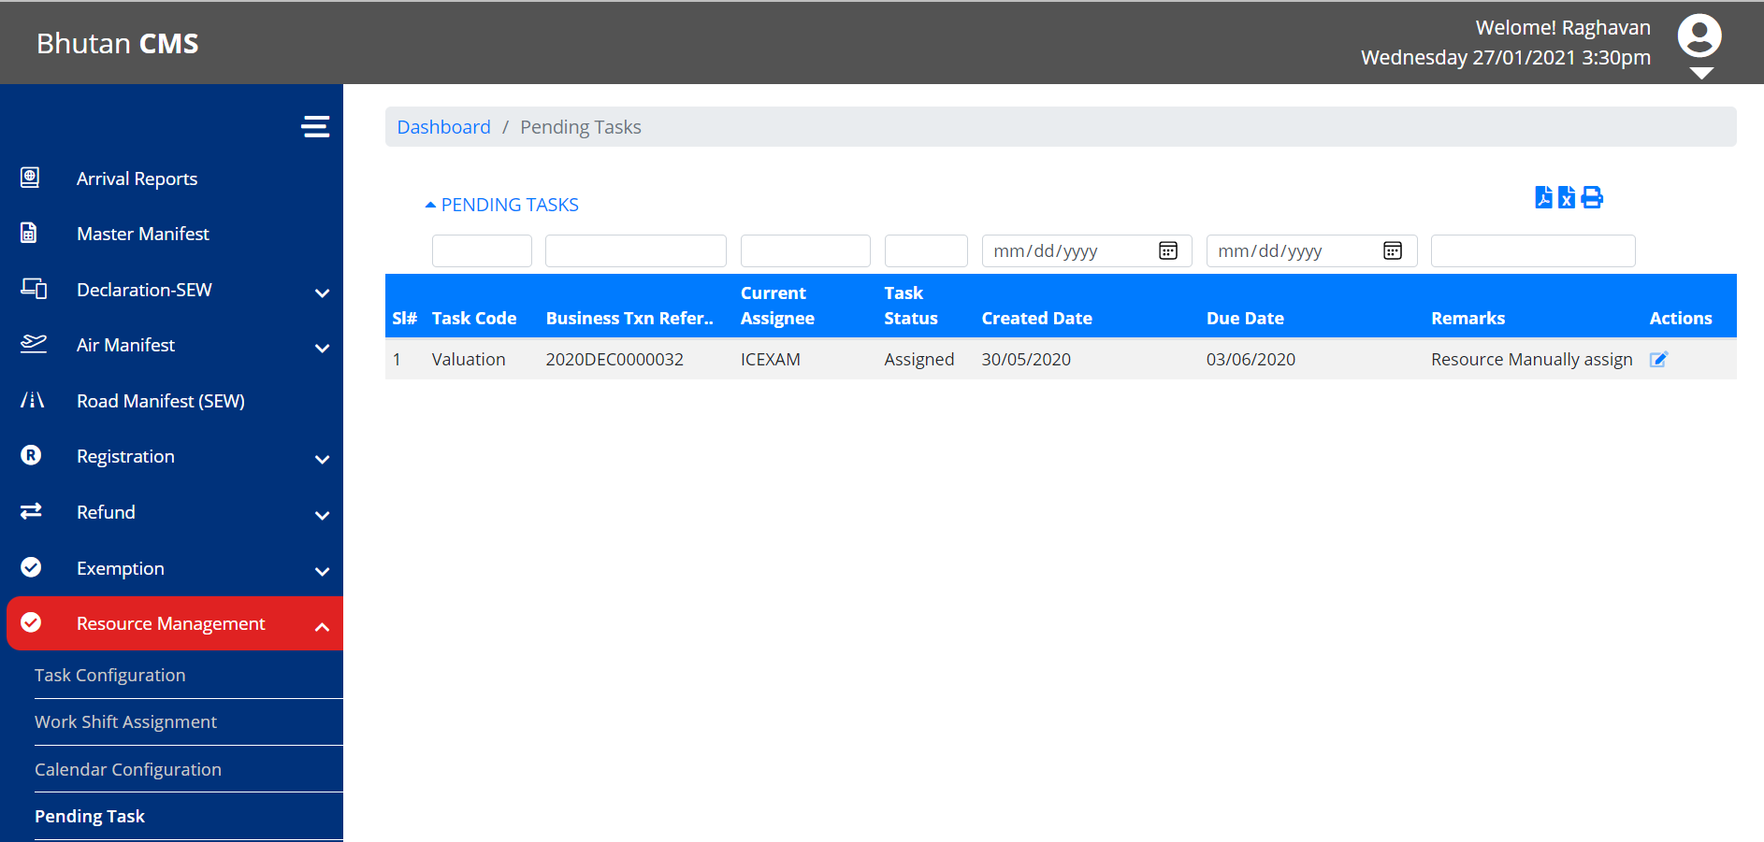
Figure 10.0
Screenshot for system Admin for pending

Dependency viewpoint

The system administration module uses quite a few classes that share information and parameter among themselves to achieve the required functionalities. The package diagram of system administration module is provided below.
logging
ORM
data
business
web
RegistrationController
Config
exception
RegistrationService
Config
exception
servicehelpers
RegistrationDAO
Config
exception
daohelpers
mysql-connector.jar
MySQL JDBC Driver
datasource
type
data
values

system database schema

ER Diagram
(Example)
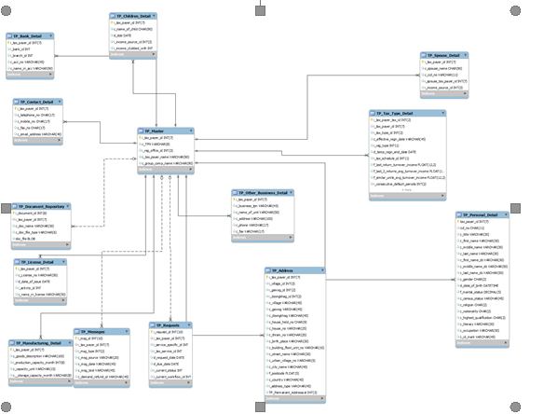

field details

Table Name | Purpose
<Table Name> | <Purpose of the table>

